AHMED SOHAIL
 | Contact: +966597978348  Email: sohailroshan@hotmail.com  Current Location: Saudi Arabia Transferable Iqama | 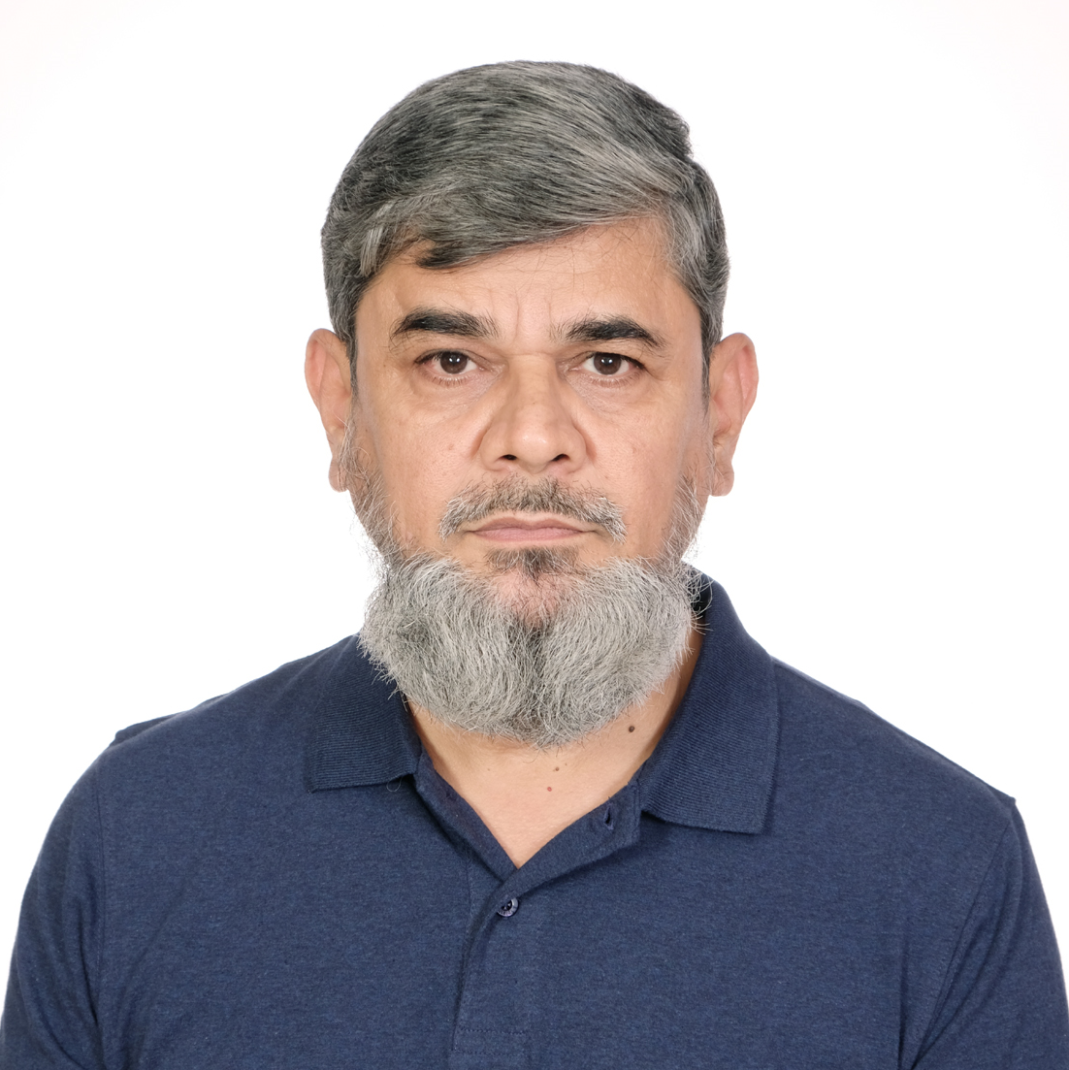
__________________________________________________________________________________________
CORE COMPETENCIES

Mechanical Instructor • Training and Facilitation • HVAC Instructor • Inspection Technical Writing • Research and Development • Team Building •Training Delivery • Heating Ventilation and Air Conditioning

ACADEMIC PROFILE
- MS (Mechanical Engineering) 3.688/4.0 GPA, National University for Sciences and Technology. 2000
- Postgraduate course in Quality and Management 1999
- Certified Vocational Trainers (TUV) by TUV Rheinald Al Ahasa Saudi Arabia 2018
- Instructor Certification Training National Center for Construction Research and Education USA 1212
- Post graduate course in Automobile Systems and other electromechanical hardware 1987
- BS. (Mechanical Engineering), University of Engineering and Technology. Pakistan 1986
- IELTS (Academic 7.0)

PROFESSIONAL EXPERIENCE

Instructor/Trainer Mechanical

TUV Rheinlander Arabia LLC (National Industrial Training Institute), (Sep 2018 to September 2020)

Jeddah Kingdom of Saudi Arabia (Current)
- Training Delivery Classroom/workshop in area of Mechanical Inspection/Maintenance.
- Conducted online training.
- Conducted Saudi Aramco Contractor Workforce Qualifications Assurance Program
- Prepared Training material/practice test for Saudi Aramco CWQAP.
- Developed training material for TUV Mechanical Inspection Program.
- Conducted TUV Mechanical Inspection Program.
- Participated in development of Heating Ventilation and Air Conditioning Curriculum
- Prepared Examinations and Practical Tasks materials

Instructor/Trainer (Welding/Mechanical)

Higher Institute for Paper and Industrial Technology, (July 2016 to Aug 2018)

Jeddah Kingdom of Saudi Arabia (Current)
- Conducted Training for Welding Trainees
- Conduct Training in Mechanical, Troubleshooting, Repair and Maintenance.
- Coordinating the Program Activities
- Curriculum development.

Technical Trainer/ Lecturer Mechanical (Heating Ventilation and Air Conditioning)

National Institute of Technology, Saudi Arabia (November 2010 to June 2016)

Trained 30 to 35 students every trimester on installation, maintenance, troubleshooting, and repair of following HVAC systems and their components
  - Central Heating and Cooling
  - Packaged Units and Air Side Systems
  - Chillers and Water Side Equipments
  - Split and Window Air Conditioning Systems
  - Domestic and Commercial Refrigeration Systems
  - Industrial Refrigeration Equipments

Manager Coordination/Training

Automobile Corporation Pakistan, Karachi. (2009-2010)
- Organized and delivered training for the vehicle maintenance and repairs
- Undertook various development projects
- Conducted training of users on specialized vehicle refuelers, bottom loading fuel trucks/trailers, box trailers and refrigerated trucks/trailers etc.
- Participated in Development and up gradation of fuel tanker

Assistant Professor (Mechanical)
Air University Islamabad Pakistan (Nov 2006 to April 2009)
Taught following Mechanical Engineering courses at undergraduate level.
- Automobile Technology
- Power Plants.
- Linear Control Systems
- Thermodynamics
- Refrigeration and Air Conditioning
- Engineering Mechanics
- Machine shop Practice.
- Welding Technology

Commissioned Officer Maintenance, Inspections, and Training

Pakistan Army (April 1986 to Oct 2006)
- Organized and delivered training for the vehicle maintenance and repairs

Managed Spare Development Project

Managed Modifications of Vehicles.

Test/trials and Evaluation of Vehicles.
- Managed repairs and maintenance programs.

Technical Projects

- Trajectory Modeling of Projectiles. (Masters Thesis Work)
- Design and Fabrication of Vertical Axis Wind Turbine. (Bachelors Project)
- Vapor Recovery System for Gasoline Tank Lorries of Shell Pakistan Ltd.

